**ANATOMY OF THE CONSTITUTION**

Read through pages 1-3 of the accompanying PDF. Then answer the questions on pages 4-5 of the PDF below. Type the correct letter or answer.

**A. Vocabulary**

1)

2)

3)

4)

5)

**B. Multiple Choice**

6)

7)

8)

9)

**C. Separate Those Powers!**

10)

11)

12)

**D. Article Match-Up**

13)

14)

15)

16)

17)

18)

**E. Table of Contents**

|  |  |
| --- | --- |
| SECTION | MISSING WORD |
| Preamble |  |
| Article I |  |
| Article II |  |
| Article III |  |
| Article IV |  |
| Article V |  |
| Article VI |  |
| Article VII |  |
| Amendments |  |

**F. Who Said It?**

|  |  |  |
| --- | --- | --- |
| QUOTE | BRANCH ? | ARTICLE ? |
| “Floor debate [on a bill] is an exhilarating experience and important duty.” |  |  |
| “The presidency has many problems, but boredom is the least of them.” |  |  |
| “We apply laws to facts. We do not apply feelings to facts.” |  |  |

**INTERPRETING IMAGES**

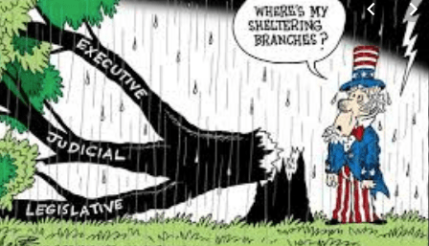

Analyze the political cartoon above and answer the following questions:

1) What do you see in the image?

2) What do you think it means?

3) What big ideas about the Constitution from today’s lesson do you think this cartoon reflects? How?